PROJECT REPORT
FOR
Foundations of Artificial Intelligence (CS23533)

AI LOST ITEM FINDER USING KNOWLEDGE REPRESENTATION AND BACKWARD CHAINING

A PROJECT REPORT

Submitted by
240701392 – PRANAV G S
240701484 – SENGATHIR M


November, 2026

BONAFIDE CERTIFICATE

Certified that this project report “AI Lost Item Finder using Knowledge Representation and Backward Chaining” is the bonafide work of PRANAV G S (240701392), SENGATHIR M (240701484) who carried out the project work under my supervision.

SIGNATURE OF THE FACULTY INCHARGE

Submitted for the Practical Examination held on ___________________.

SIGNATURE OF THE INTERNAL EXAMINER
TABLE OF CONTENTS

CHAPTER NO. TITLE PAGE NO.
ABSTRACT 4
1 INTRODUCTION 5
2 LITERATURE REVIEW 7
3 PROPOSED SYSTEM 10
3.1 ARCHITECTURE DIAGRAM 10
4 MODULES DESCRIPTION 14
4.1 MODULE 1 14
4.2 MODULE 2 14
5 IMPLEMENTATION AND RESULTS 16
5.1 EXPERIMENTAL SETUP 16
5.2 RESULTS 17
6 CONCLUSION AND FUTURE WORK 22
7 REFERENCES 23

ABSTRACT

People frequently misplace everyday belongings such as identity cards, mobile phones, wallets, keys, chargers, earphones and books. Locating them usually depends on trying to remember recent activities and then checking several places at random. The AI Lost Item Finder is a lightweight knowledge-based system that applies classical Artificial Intelligence techniques, namely Knowledge Representation, First-Order Logic (FOL) and Backward Chaining, to reason about where a misplaced object is most likely to be.
The system stores relationships between items, containers, activities and locations as FOL-style facts and IF–THEN rules. When the user selects a lost item, the inference engine starts from the goal LikelyAt(Item, ?Location) and works backward through the rules. It asks the user only the questions needed to prove or reject each hypothesis, converts every answer into a new fact in a session fact store and attaches a certainty factor to each conclusion. The explanation module then reports the most probable location, the confidence level, the rule that produced the conclusion, alternative locations and the full reasoning trace.
The system was implemented in Python 3 using only the standard library and tested on six scenarios covering seven rule paths, including a case in which the user cannot answer any question. In every scenario the system returned the expected location. Across the six scenarios the goal-directed questioning asked 28 questions, compared with 66 questions for a fixed questionnaire that asks every possible question, a reduction of about 58 per cent. Each inference completed in under one millisecond. The results are limited to scripted test scenarios and do not represent a user study.

CHAPTER - 1
INTRODUCTION

1.1 Background
Misplacing personal belongings is one of the most common everyday problems. Students, in particular, move between home, classrooms, libraries and canteens with several small items such as identity cards, phones, earphones, chargers and books. When one of these items goes missing, the usual approach is to retrace activities from memory and search likely places one by one. This is slow, depends heavily on recall and often involves checking the same places repeatedly.
Artificial Intelligence offers well-established techniques for this type of reasoning. Knowledge Representation allows facts about the world to be stored in a structured, machine-readable form. First-Order Logic provides a precise language for expressing relationships such as "the item was taken out of the bag" or "the bag is in the classroom". Inference mechanisms such as backward chaining can then reason from a hypothesis back to the facts needed to support it.
The AI Lost Item Finder applies these ideas to a practical daily problem. Instead of asking the user to remember everything at once, the system asks a short sequence of focused questions, chosen by the reasoning process itself, and explains why it recommends a particular location.
1.2 Problem Statement
The project addresses the problem of identifying the most probable location of a misplaced personal item using information about the user's recent activities. The system must represent knowledge about items, containers, activities and locations; collect relevant information from the user; infer candidate locations through logical reasoning; rank those candidates by confidence; and present the reasoning behind its recommendation.
A further challenge is that the user may not remember every detail. The system should therefore ask only the questions that matter for the current hypothesis, accept "Not sure" as an answer and still provide a useful, clearly labelled low-confidence suggestion when little information is available.
1.3 Objectives
- Represent items, containers, activities and locations as First-Order-Logic style facts.
- Encode domain knowledge as IF–THEN rules with certainty factors.
- Implement a backward-chaining inference engine that works from location hypotheses to supporting facts.
- Ask the user only those questions that are required to prove the current hypothesis.
- Store answers in a session fact store so that no question is asked twice.
- Report the most probable location, confidence level, rule applied and alternative locations.
- Provide a step-by-step reasoning trace that explains each conclusion.
1.4 Scope of the Project
The project is a console-based software system implemented in Python. It covers seven common items (college ID card, mobile phone, wallet, keys, charger, earphones and book), ten locations and six inference rules. The scope includes question generation, fact generation, backward chaining, certainty-factor ranking and explanation. The system does not use physical tracking hardware such as GPS, Bluetooth tags or cameras, and it does not learn from previous sessions; these are identified as future extensions.
1.5 Significance
The project demonstrates how classical symbolic AI techniques, often associated with large expert systems in medicine or engineering, can be applied to a simple everyday task. Because every conclusion is derived from explicit rules, the system is transparent: the user can see exactly which facts and which rule led to a recommendation. The design is also easy to extend, since new items, locations or rules can be added to the knowledge base without changing the inference engine.

CHAPTER - 2
LITERATURE REVIEW

Knowledge-based reasoning is one of the oldest areas of Artificial Intelligence. Instead of learning patterns from large datasets, a knowledge-based system stores explicit facts and rules supplied by a domain expert and uses an inference procedure to derive conclusions. This section reviews the techniques on which the AI Lost Item Finder is built.
2.1 Knowledge-Based Expert Systems
A knowledge-based system separates domain knowledge from the mechanism used to reason over that knowledge. A typical system contains a knowledge base of facts and rules, an inference engine that derives new conclusions, a working memory that holds facts about the current case and an explanation facility that justifies the result. Such systems have been used for medical diagnosis, equipment fault-finding and decision support.
This architecture applies directly to the Lost Item Finder. Facts about the user's recent activities form the working memory, rules connecting activities to locations form the knowledge base, and the inference engine combines the two to determine where an item is likely to be.
2.2 Rule-Based Representation and First-Order Logic
Rule-based systems represent knowledge as IF–THEN rules, also called production rules. Each rule states that if a set of conditions holds, a conclusion may be drawn. When these rules are written in First-Order Logic, they can contain variables that range over objects, which allows one rule to apply to many cases. For example, the rule Removed(?i, ?c) ∧ RemovedAt(?i, ?l) → LikelyAt(?i, ?l) applies to any item ?i, container ?c and location ?l.
Rules of this form, with a single conclusion and a conjunction of conditions, are known as Horn clauses. Horn clauses are important because they allow efficient inference procedures such as forward and backward chaining, and they form the basis of logic programming languages such as Prolog.
2.3 Forward and Backward Chaining
Forward chaining is data-driven. It starts from known facts, repeatedly applies any rule whose conditions are satisfied and adds the conclusions to the set of facts until no new facts can be derived or a goal is reached. Forward chaining is suitable when all relevant data is available in advance.
Backward chaining is goal-driven. It starts from a goal or hypothesis and searches for rules whose conclusion matches that goal. The conditions of the matching rule become new sub-goals, which are proved recursively, either from existing facts, from other rules or by asking the user. Backward chaining is suitable when the number of possible conclusions is small and gathering data is costly, because it only seeks information that is relevant to the current hypothesis.
For the Lost Item Finder, information comes from the user, and every question costs the user time and effort. Backward chaining is therefore the better choice: the system starts from the goal LikelyAt(Item, ?Location) and asks only the questions needed to prove or reject each candidate explanation.
2.4 Unification
Unification is the process of finding variable bindings that make two logical expressions identical. When the inference engine matches the goal LikelyAt(ID, ?l) against the rule conclusion LikelyAt(?i, ?l), unification binds ?i to ID. The binding is then carried into the rule's conditions, so that the next sub-goal becomes Removed(ID, ?c). Unification is what allows general rules containing variables to be applied to a specific case.
2.5 Certainty Factors
Real-world reasoning is rarely certain. The MYCIN medical expert system introduced certainty factors as a practical way of expressing how strongly a rule's conditions support its conclusion, on a scale where 1.0 represents full confidence. A conclusion reached through a strong rule can then be ranked above one reached through a weak rule.
The Lost Item Finder attaches a certainty factor to each rule. For example, an item that was last used in a place and not moved afterwards is very likely to still be there (0.90), whereas the place where an item is usually kept is only a weak fallback (0.30). These values are used to rank candidate locations and to decide when the system is confident enough to stop asking questions.
2.6 Research Gap and Relevance
Knowledge-based and rule-based systems have been widely applied to specialised domains such as diagnosis, engineering, law and information retrieval. Existing lost-item solutions, by contrast, mostly rely on physical tracking devices such as Bluetooth tags, which require the item to be tagged in advance. The proposed project applies symbolic reasoning to the everyday problem of locating untagged personal belongings, using only the user's memory of recent activities, and makes the reasoning process visible to the user.

CHAPTER - 3
PROPOSED SYSTEM

The proposed AI Lost Item Finder is a lightweight knowledge-based system that helps users identify the most probable location of a misplaced object. The user selects the lost item and answers a short sequence of questions. Each answer is converted into a logical fact. The inference engine uses backward chaining to test location hypotheses against the rules in the knowledge base and reports the best-supported location together with its reasoning.
For example, if a user reports a lost college ID card and states that the card was taken out of the bag while the user was at the study table, the system derives the facts Removed(ID, Bag) and RemovedAt(ID, StudyTable). Rule R3 then concludes LikelyAt(ID, StudyTable) with a confidence of 80 per cent.
3.1 ARCHITECTURE DIAGRAM
The system consists of a user interface, an item and question bank, a knowledge base, a session fact store, a fact-generation component, an inference engine with rule matching, and an explanation and result module. The flow of information between these components is shown in Figure 3.1.
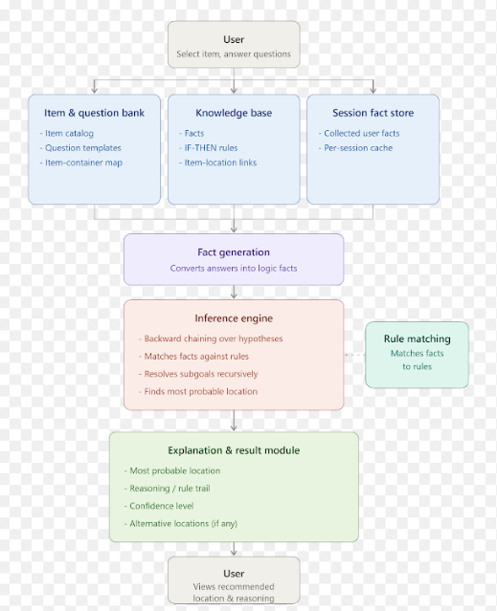
Figure 3.1: System architecture of the AI Lost Item Finder.

3.2 Existing System and its Limitations
In the existing approach, a person relies on memory and manual searching to find a misplaced object. For example, a student who loses an identity card tries to remember where it was last used and then physically checks several possible places. Tracking devices exist, but only for items that have been tagged in advance.
- Memory-dependent: the user has to recall all previous activities and locations unaided.
- No systematic reasoning: possible locations are usually checked at random.
- Time-consuming: the user may need to search many places before finding the item.
- No formal knowledge representation: relationships between objects, activities and locations are not represented logically.
- No explanation: there is no reasoning trail showing why one location is more likely than another.
3.3 Functional Requirements
- Display the list of supported items and allow the user to select the lost item.
- Generate natural-language questions from the askable predicates in the knowledge base.
- Accept Yes, No, Not sure or a location as answers, and convert them into logical facts.
- Apply backward chaining with unification to prove LikelyAt(Item, ?Location).
- Rank candidate locations using rule certainty factors and stop once a confident hypothesis is found.
- Display the most probable location, confidence, rule applied, alternatives and number of questions asked.
- Display the complete reasoning trace for the session.
3.4 Non-Functional Requirements
Explainability is the most important quality: every recommendation must be traceable to explicit facts and rules. Efficiency matters because every question costs the user effort, so the system should ask as few questions as possible and should never repeat one. Extensibility is achieved by keeping the knowledge base separate from the inference engine, so new items, locations and rules can be added as data. Robustness requires the system to handle uncertain answers and still return a clearly labelled result. Portability is achieved by using only the Python standard library.
3.5 System Workflow
- Item selection: the user chooses the lost item from the item catalogue.
- Goal setting: the inference engine sets the goal LikelyAt(Item, ?l).
- Rule selection: rules whose conclusion unifies with the goal are tried in order of certainty factor.
- Sub-goal proof: each condition is proved from known facts or, if it is askable, by asking the user.
- Fact generation: answers are stored in the session fact store as new facts.
- Ranking: proved locations are ranked by certainty factor; reasoning stops at the first conclusion with confidence of 0.75 or more.
- Explanation: the result and reasoning trace are displayed to the user.
3.6 Knowledge Representation
Knowledge is expressed as predicates in First-Order-Logic style. Static facts, such as which items are chargeable or usually carried in a pocket, are loaded from the item bank. Askable predicates are facts that the system obtains from the user. Table 3.1 lists the rules in the knowledge base.
Table 3.1: Rules in the knowledge base
Rule | IF (conditions) | THEN | CF
R1 | LastUsedAt(?i, ?l) ∧ NotMovedSince(?i) | LikelyAt(?i, ?l) | 0.90
R2 | KeptIn(?i, ?c) ∧ ContainerAt(?c, ?l) | LikelyAt(?i, ?l) | 0.85
R3 | Removed(?i, ?c) ∧ RemovedAt(?i, ?l) | LikelyAt(?i, ?l) | 0.80
R4 | Chargeable(?i) ∧ Charging(?i) ∧ ChargedAt(?i, ?l) | LikelyAt(?i, ?l) | 0.80
R5 | PocketItem(?i) ∧ ChangedClothes | LikelyAt(?i, LaundryBasket) | 0.70
R6 | TypicalPlace(?i, ?l) | LikelyAt(?i, ?l) | 0.30

Example facts generated during a session include Removed(ID, Bag), RemovedAt(ID, StudyTable), KeptIn(Book, Bag) and ContainerAt(Bag, Classroom). Static facts include Chargeable(Phone), PocketItem(Wallet) and TypicalPlace(Keys, FrontDoor).
3.7 Advantages of the Proposed System
- Systematic search: locations are inferred from logical rules rather than checked at random.
- Fewer questions: backward chaining asks only what is relevant to the current hypothesis.
- Explainable results: the reasoning trace shows exactly which facts and rule produced the answer.
- Handles uncertainty: certainty factors rank alternatives, and "Not sure" answers are accepted.
- Easy to extend: new items, locations and rules can be added without changing the engine.

CHAPTER - 4
MODULES DESCRIPTION

4.1 MODULE 1 – KNOWLEDGE BASE AND FACT GENERATION
Module 1 holds all the knowledge the system reasons with. It has three parts: the item and question bank, the knowledge base of rules, and the session fact store.
The item and question bank lists the supported items together with their properties: the containers each item can be kept in (bag, pocket or wallet), whether it is chargeable, and the places where it is typically kept. It also holds natural-language templates for each askable predicate, so that a sub-goal such as Removed(ID, Bag) is presented to the user as "Did you take the college id card out of your bag?".
The knowledge base stores the six rules shown in Table 3.1. Each rule is held as a tuple containing an identifier, a list of condition predicates, a conclusion predicate, a certainty factor and a short English description used in explanations. Because the rules are data, they can be edited or extended without changing the inference code.
The session fact store holds the facts that are true for the current session. It starts with static facts derived from the item bank and grows as the user answers questions. An answer of Yes adds the corresponding ground fact; a location answer binds the variable in the question and adds the resulting fact; No and Not sure add nothing. All answers are cached so that the same question is never asked twice.
RULES = [
("R1", [("LastUsedAt","?i","?l"), ("NotMovedSince","?i")],
("LikelyAt","?i","?l"), 0.90, "Item stays where it was last used"),
("R3", [("Removed","?i","?c"), ("RemovedAt","?i","?l")],
("LikelyAt","?i","?l"), 0.80, "Item is near where it was taken out"),
...
]
Listing 4.1: Rules represented as data in the knowledge base.
4.2 MODULE 2 – INFERENCE ENGINE AND EXPLANATION
Module 2 performs the reasoning. The inference engine receives the goal LikelyAt(Item, ?l) and tries the rules in descending order of certainty factor, so the most reliable explanations are tested first. For each rule, unification binds the rule's variables to the selected item, and the rule's conditions are proved one by one.
To prove a condition, the engine first searches the session fact store for a matching fact. If none exists and the predicate is askable, the engine asks the user. Yes/No questions are asked for ground predicates, and multiple-choice questions listing the known locations are asked for predicates that contain an unbound location variable. Proof proceeds depth-first using Python generators, so that alternative bindings can be explored when a condition fails.
def prove_all(self, goals, b):
if not goals:
yield b # all conditions proved
return
for nb in self.prove_goal(goals[0], b): # fact store or ask user
yield from self.prove_all(goals[1:], nb)
Listing 4.2: Recursive backward chaining over the conditions of a rule.
Each proved location is recorded with the certainty factor of the rule that produced it, keeping the highest value if a location is reached by more than one rule. As soon as a location is proved with a certainty factor of 0.75 or more, the engine stops asking questions. If no strong rule succeeds, the fallback rule R6 suggests the item's usual places with a low confidence of 30 per cent, so the user always receives a clearly labelled suggestion.
The explanation and result module presents the outcome: the most probable location, the confidence as a percentage, the rule that produced the conclusion with its English description, any alternative locations with their confidence, and the number of questions asked. It also prints the reasoning trace, which records every goal, every rule tried, every question asked with its answer and every conclusion proved.
4.3 Module Interaction
The two modules interact through the session fact store. Module 1 supplies the rules, static facts and question templates; Module 2 uses them to prove the goal and writes each new answer back into the fact store as a fact. This separation means that the same inference engine works for any item, location or rule added to the knowledge base, and that every conclusion can be traced back to the facts and rule that produced it.

CHAPTER - 5
IMPLEMENTATION AND RESULTS

5.1 EXPERIMENTAL SETUP
The system was implemented in Python 3 using only the standard library, so it runs on any computer with Python 3.8 or later and needs no external packages. The tests reported here were run with Python 3.13.17. The program consists of the item and question bank, the knowledge base, the inference engine and the explanation module in a single file, lost_item_finder.py, together with a test script, run_scenarios.py, that runs fixed scenarios with scripted answers.
The knowledge base contains seven items, ten locations, six rules and nine askable predicates. The confidence threshold for stopping the search is 0.75.
5.1.1 Evaluation Criteria
Each scenario was evaluated using the following measures: whether the predicted location matched the expected location; the confidence of the prediction; the rule that produced it; the number of questions asked; and the inference time. To measure the benefit of goal-directed questioning, the number of questions asked was compared with the number a fixed questionnaire would need, that is, one question for every askable condition of every applicable rule for that item.
5.1.2 Test Scenarios
Six scenarios were designed so that each rule path is exercised at least once, including a case in which the user answers "Not sure" to every question. Table 5.1 summarises them.
Table 5.1: Test scenarios
ID | Item | Situation described by the user | Expected location
S1 | College ID card | Took the ID card out of the bag while at the study table | StudyTable
S2 | Mobile phone | Put the phone on charge in the bedroom | Bedroom
S3 | Keys | Last used the keys at the front door and did not move them | FrontDoor
S4 | Wallet | Changed clothes after coming home | LaundryBasket
S5 | Book | Book was moved; it is in the bag, which is in the classroom | Classroom
S6 | Earphones | User is not sure about anything | Bag (usual place)

5.2 RESULTS
5.2.1 Sample Run: College ID Card
Figure 5.1 shows the complete run for scenario S1. Rule R1 fails because the user is not sure where the card was last used. Rule R2 fails for both the bag and the wallet. Rule R3 succeeds: the user confirms the card was taken out of the bag and chooses StudyTable as the place. The system concludes LikelyAt(ID, StudyTable) with 80 per cent confidence and stops after five questions.
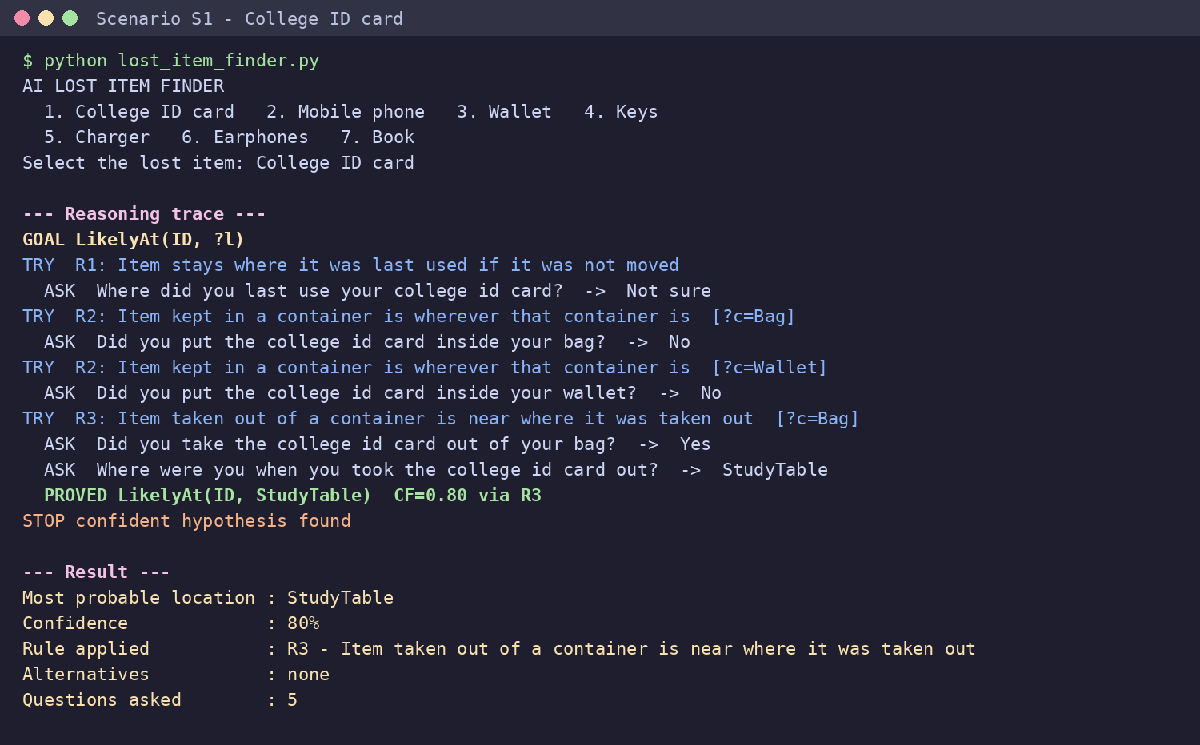
Figure 5.1: Reasoning trace and result for the lost college ID card (S1).

5.2.2 Container Reasoning: Book
In scenario S5, the user last used the book in the library but says it was moved afterwards, so rule R1 is rejected. Rule R2 then establishes that the book was placed in the bag and that the bag is now in the classroom. The system chains these two facts and concludes that the book is in the classroom with 85 per cent confidence, after four questions.
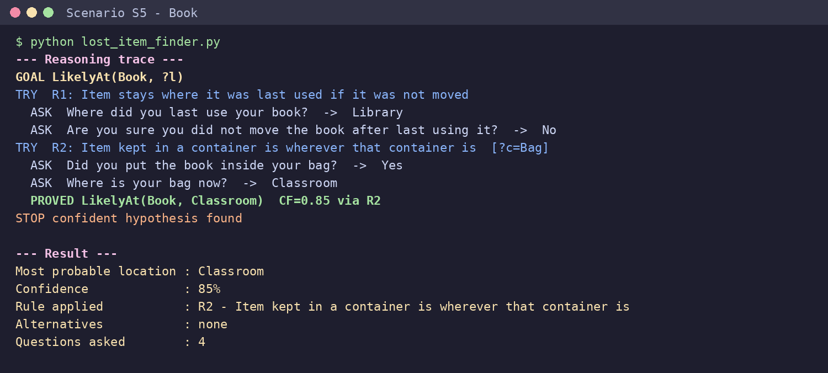
Figure 5.2: Chaining through a container for the lost book (S5).

5.2.3 Ranked Alternatives: Wallet
In scenario S4, rules R1 to R3 fail, and R4 does not apply because a wallet is not chargeable, so no question is asked for it. Rule R5 succeeds because the wallet is a pocket item and the user changed clothes, giving LaundryBasket at 70 per cent. As this is below the 0.75 threshold, the engine also applies the fallback rule and lists the bag and bedroom as alternatives at 30 per cent each.
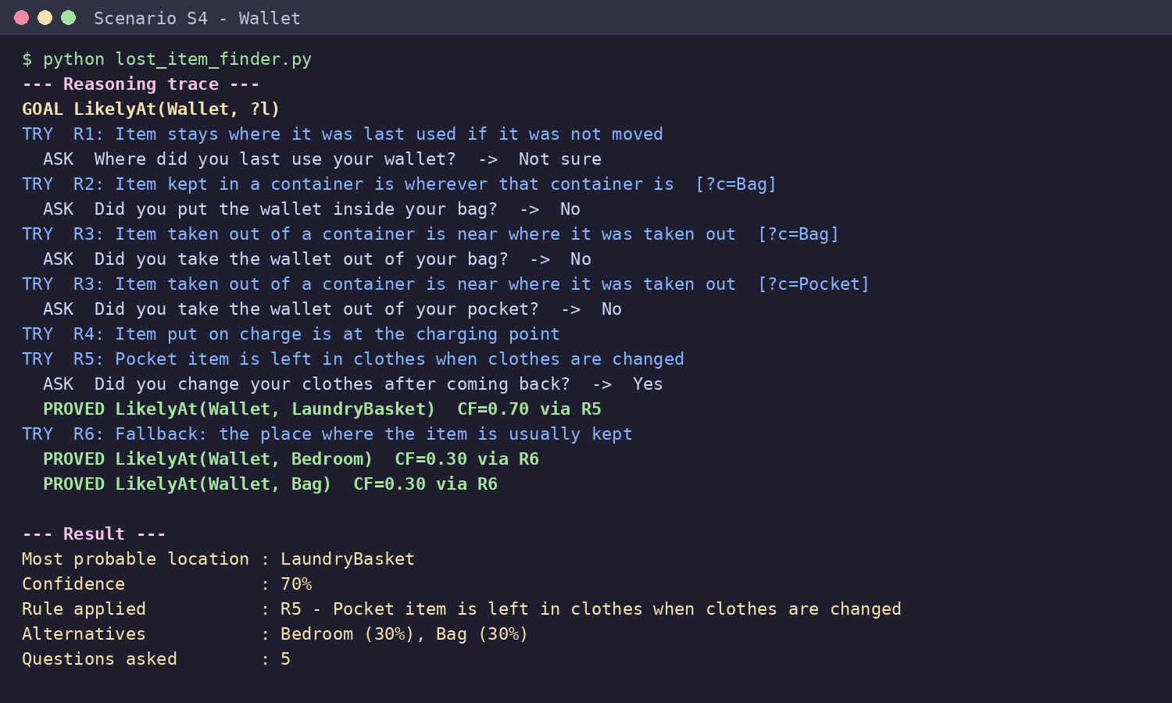
Figure 5.3: Primary location and ranked alternatives for the lost wallet (S4).

5.2.4 Uncertain User: Earphones
In scenario S6, the user answers "Not sure" to every question. No strong rule can be proved, so the system falls back on rule R6 and suggests the usual places for earphones, the bag and the bedroom, with a clearly stated confidence of 30 per cent. This shows that the system still gives useful guidance when little information is available, without overstating its certainty.
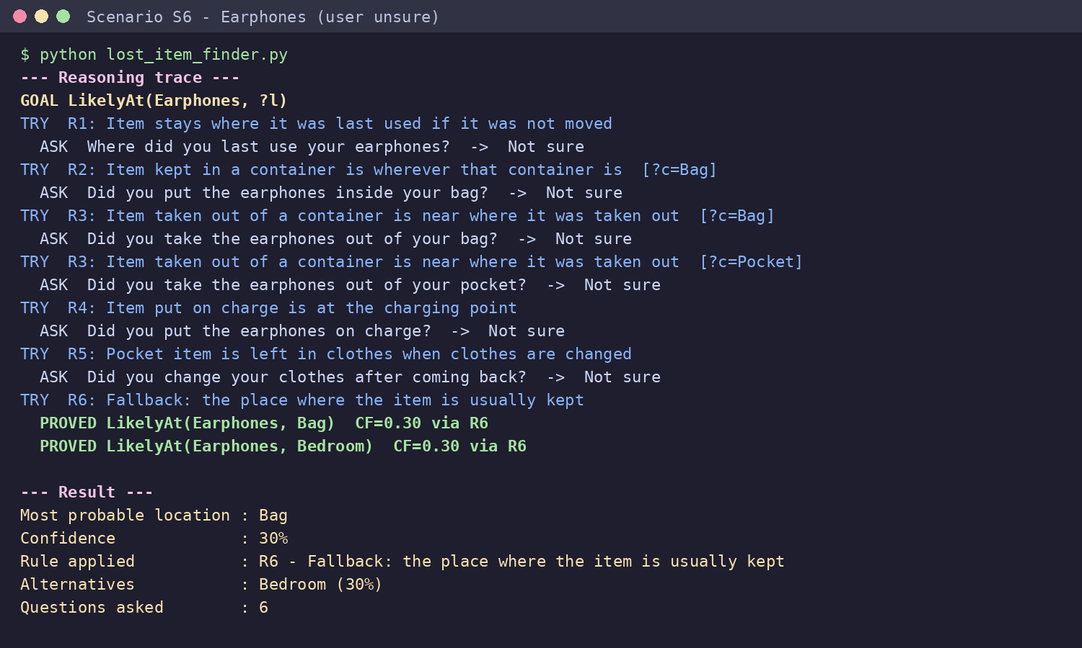
Figure 5.4: Low-confidence fallback when the user is unsure (S6).

5.2.5 Summary of Results
Table 5.2 summarises the results for all six scenarios.
Table 5.2: Results for all test scenarios
ID | Item | Predicted location | CF | Rule | Questions asked | Fixed question-naire | Correct
S1 | College ID card | StudyTable | 80% | R3 | 5 | 13 | Yes
S2 | Mobile phone | Bedroom | 80% | R4 | 6 | 11 | Yes
S3 | Keys | FrontDoor | 90% | R1 | 2 | 11 | Yes
S4 | Wallet | LaundryBasket | 70% | R5 | 5 | 11 | Yes
S5 | Book | Classroom | 85% | R2 | 4 | 9 | Yes
S6 | Earphones | Bag | 30% | R6 | 6 | 11 | Yes
 | Total |  |  |  | 28 | 66 | 6/6

- The predicted location matched the expected location in all six scenarios.
- Every rule in the knowledge base (R1 to R6) produced the final answer in at least one scenario.
- Backward chaining asked 28 questions in total, compared with 66 for a fixed questionnaire, about 58 per cent fewer.
- The fewest questions (2) were needed for S3, where the first and strongest rule succeeded immediately.
- Every inference completed in under one millisecond (maximum 0.11 ms).
5.2.6 Question Efficiency
Figure 5.5 compares the number of questions asked by the backward-chaining engine with the number a fixed questionnaire would ask for the same item. The saving is largest when a high-confidence rule succeeds early, as in S3, and smallest when the user is unsure and the engine has to try every rule, as in S6.
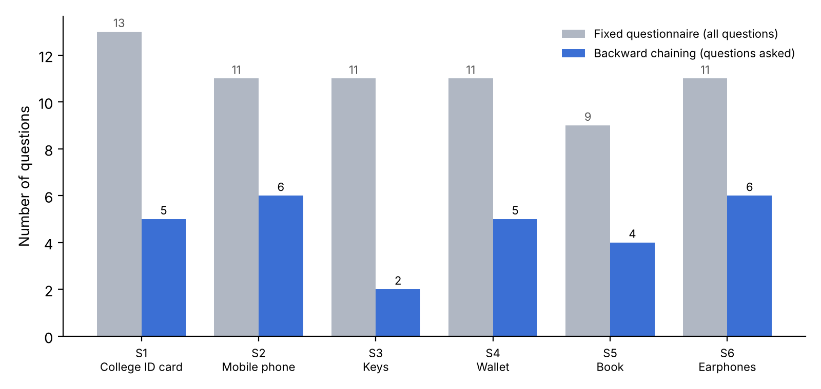
Figure 5.5: Questions asked by backward chaining compared with a fixed questionnaire.

5.2.7 Discussion
The results show that goal-directed backward chaining suits this problem. Because the rules are tried in order of certainty factor, the system tests the most reliable explanations first and stops as soon as one is confirmed, which cuts the number of questions substantially. Static facts also help: for non-chargeable items such as the wallet, the condition Chargeable(?i) fails immediately and the charging question is never asked. The reasoning trace makes every step visible, so the user can see why a location was suggested and judge whether it is plausible.
5.2.8 Limitations
The scenarios use scripted answers that are consistent with the expected location, so they test the correctness of the reasoning rather than real-world accuracy; a user study would be needed to measure how often the suggested location is actually right. The certainty factors were chosen by the developers and have not been calibrated against real data. The knowledge base is small, with seven items and six rules, and the system does not combine evidence from several rules that point to the same location.

CHAPTER - 6
CONCLUSION AND FUTURE WORK

6.1 Conclusion
The AI Lost Item Finder shows how Knowledge Representation, First-Order Logic and backward chaining can be applied to the everyday problem of locating misplaced belongings. Knowledge about items, containers, activities and locations is stored as explicit facts and rules, and a backward-chaining inference engine with unification works from location hypotheses back to the facts that support them, asking the user only what is needed.
In six test scenarios covering every rule, the system returned the expected location each time, asked about 58 per cent fewer questions than a fixed questionnaire and explained every conclusion with a complete reasoning trace. These results are limited to scripted scenarios and should not be read as a measure of real-world accuracy.
6.2 Future Work
- Conduct a user study to measure how often the suggested location is correct in practice.
- Combine certainty factors when several rules support the same location.
- Learn rule confidence values from past sessions in which the item was found.
- Add time-based reasoning, such as the order of recent activities.
- Expand the knowledge base with more items, locations and rules.
- Build a graphical or mobile interface with buttons instead of numbered options.
- Integrate optional tracking data, such as the last Bluetooth connection of earphones, as additional facts.
- Add voice input so that the user can describe recent activities in natural language.
6.3 Future Evaluation Plan
A future evaluation should collect real cases from volunteers who have misplaced an item. Each participant would answer the system's questions, and the suggested location would be compared with where the item was actually found. The evaluation should record top-1 and top-3 accuracy, the number of questions asked and the participant's rating of the explanation, and should compare the system with a fixed questionnaire and with unaided searching.

CHAPTER - 7
REFERENCES

- Russell, S. and Norvig, P. (2021) Artificial Intelligence: A Modern Approach. 4th edn. Pearson.
- Buchanan, B. G. and Shortliffe, E. H. (1984) Rule-Based Expert Systems: The MYCIN Experiments of the Stanford Heuristic Programming Project. Addison-Wesley.
- Shortliffe, E. H. and Buchanan, B. G. (1975) ‘A Model of Inexact Reasoning in Medicine’, Mathematical Biosciences, 23(3–4), pp. 351–379.
- Giarratano, J. C. and Riley, G. D. (2005) Expert Systems: Principles and Programming. 4th edn. Thomson Course Technology.
- Jackson, P. (1998) Introduction to Expert Systems. 3rd edn. Addison-Wesley.
- Kowalski, R. (1974) ‘Predicate Logic as Programming Language’, Proceedings of IFIP Congress 74, pp. 569–574.
- Bratko, I. (2012) Prolog Programming for Artificial Intelligence. 4th edn. Pearson.
- Python Software Foundation (2026) Python 3 Documentation. Available at: https://docs.python.org/3/.

